|  |
| --- |
| **2019-01-10** |

* Ask Andrew: Can we start prototyping alcohol pump while we design the LOX pump?
* We will be running tests with gallons of IPA to determine efficiency of the pump. Too many unknowns to determine on paper. Last year’s was 52%.
* Phil presented his calculations and current design update.
* Julio discussed block diagram for controls

|  |
| --- |
| **2019-01-08** |

* Talk to Mike about possibly using CNC machine during ME 240L labs since he is already in there. Otherwise we will need to schedule times to using the machine shop.
* With updates from PSAS - Are we going to build for LOX or nitrogen? Look at this again in a few weeks as we make the first for IPA.
* Will be doing an open-faced Barkse impeller.
* Thursday Movie Day during next meeting - 3:00 presentation of last capstone
* Work to mitigate pressure that the pumps needs from the beginning

**Action Items:**

* Finalize CAD
* Practice MasterCAM with CAD
* Practice path in plastic for ISO design
* Flow rates
* Bring an HDMI cable next meeting
* January 15th Presentation: Phil and Jonas
* January 22nd Presentation: Julio and Henry
* February 19th Presentation: Nick and Shayli

|  |
| --- |
| **2019-01-17** |

* Jonas and Nick are working in the machine shop, machining the plastic model.
* The team split up into two individual teams.
  + team one working on flow measurement
    - Julio, Henry
  + Team two working on flow measurement
    - Phil, Shayli
* Discussing purchases for our project.

|  |  |  |  |
| --- | --- | --- | --- |
| **Quantity** | **Items** | **Budget** | **Remark** |
| 2 | LabJack U6 | $319/ea | Sensor control |
| 2 | CB37 terminal boards | $46/ea | Sensor control |
| 2 | CB15 terminal boards | $37/ea | Sensor control |
| 4 | Pressure transducers |  | TBD |
| 5 | Pressure transducers |  | LOX |
| 2 | 1530 series motor | $460/ea | motor |

* The cost in total, for now, could be $1600 for sensors, $1000 for motors, $150 for impellers. Approximate $1716.

|  |
| --- |
| **2019-01-24** |

Recap from the last meeting on Tuesday

* James suggests us that we should redesign the entire system.
* He also suggests us that we should machine the impeller instead of print it.

Purchases:

* Toolbox for storing our tools and capstone stuff.

Agenda:

* Dissemble the old pump, determine which section we are going to redesign.
* Impeller design:
  + Fasten method
  + 10 vane(test)
  + Purchasing - Quote
* Purchasing request sheet.

|  |
| --- |
| **2019-01-31** |

* Recap from Tuesday’s PSAS general meeting.
  + PSAS team is going to X-ray scan another 3D model engine.
  + Otherwise, they are going to use 4kN or 8kN engine.
  + 8kN feasibility
    - Can we reuse the values and lines?
    - New tanks
    - Test stand is rated for it
  + 4kN feasibility
* Do new calculations to determine either 4kN or 8kN is fesible to make.
* Our pump will not be used on the next test stand, but our design and data will be used in future designs.
* The following week, do research and calculations for new pumps.
  + Either build a bigger pump
  + Or redesign a new pump
  + Depend on calculations, find out from the old code.
* New ideas on how to fix impeller and pump.
* Continue searching for material.

Tasks for the week:

* Machining: Continue plastic casing machining.
* Shaft:
  + Material Research
  + Manufacture design
* Casing:
  + Material Selection(LOX)
* Scaling: 4kN, 8kN

|  |
| --- |
| **2019-02-07** |

Today’s agenda:

* Pressure Transducers/Labjacks have arrived
* Shaft/Impeller Design Decision
  + New design idea will be modeled over this weekend, Nick and Phil will work on CAD design, after that we will do an FEA on those parts.
* Design Spec Decision

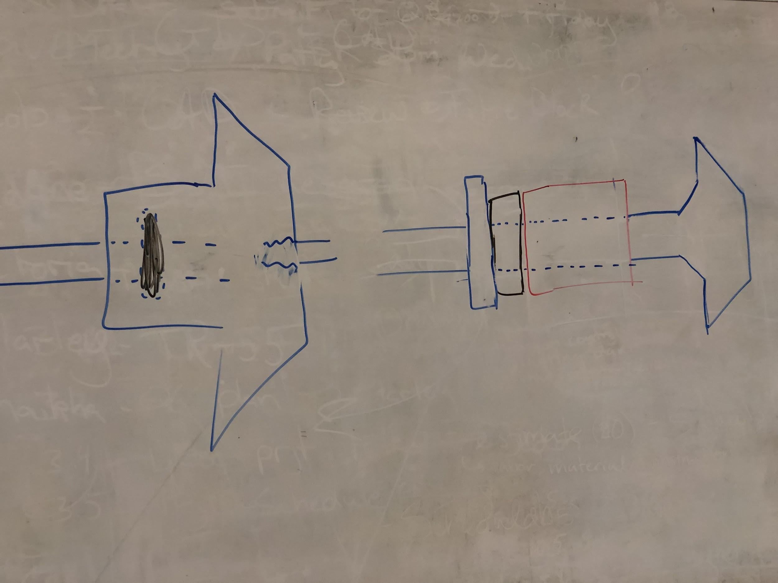

* Test Apparatus Requirement
* Next order
  + Motor is urgent
* Tubing
* Advisor

Measurements for 411

* Design

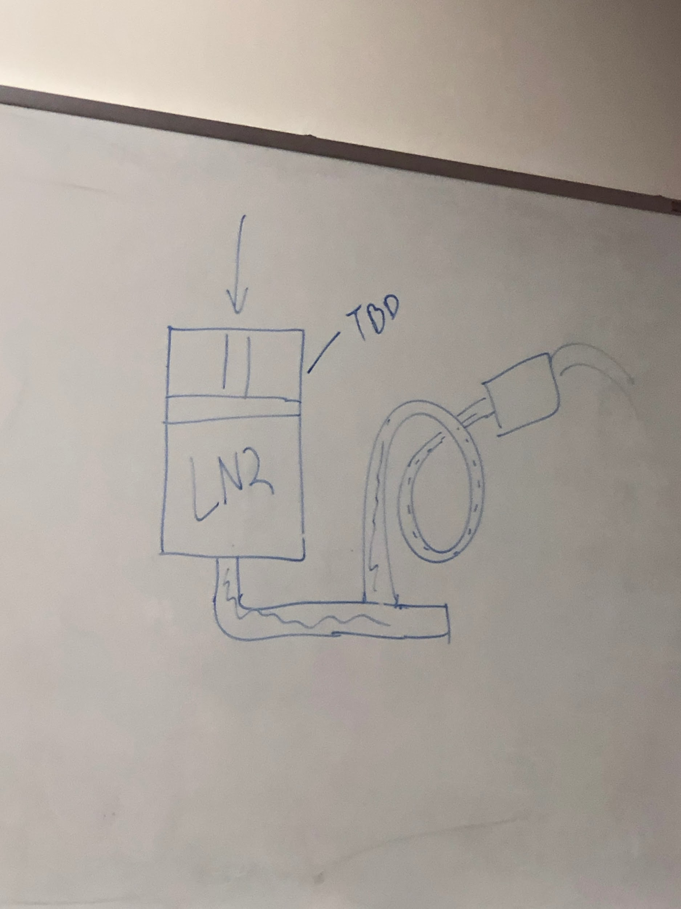

|  |
| --- |
| **2019-02-14** |

Attendees: Julio, Nick, Phil, Shayli, Jonas, Henry, Dr. Baldur, Andrew

Today’s Agenda:

* Project update
* Progress report report
* IAC abstract
* Final presentation content
* Shaft, Impeller design update
* Electronic motor/ESC/Battery update
* System Engineering Meeting with Hakun

Meeting Notes:

* Updating with Dr. Baldur:
  + EFS system design, we showed him the design diagram.
  + Second, we showed him the testing design with a cad file picture.
  + Updating on recent design.
  + Impeller and shaft design.
  + Gantt Chart update.
* Getting advise from Baldur on presenting our system, and finding the problem during our design.
* Getting advise from Baldur on designing procedures, such as design risk factors, and keep updating with sponsors.
* Recap from Jonas on making the plastic pump.
* Discussing the actual pump design.
* Presenting the customer and engineering requirement to Baldur.

Meeting with Andrew:

* Discussing the big issue with our design.
* The risk side, the shaft, and the coupling would cause problems. (Bearing would help.)
* Get our prototype as soon as possible, we have to find out if the design is usable fast, if not, we will need to figure out another solution.
* Discussing the flow meter.
* Hand-off presentation, 1-2Hr presentation, be prepared of all kinds of question.

|  |
| --- |
| **2019-02-21** |

Agenda:

* Abstract for IAC
* Plastic casing assembly procedure and follow up
  + Hardware (bolts and tubings). Case 1 and 2 machining features.
* Pressure transducer calibration and data extraction(tool made)
* Motor mount update (machine today?)
* Fitting (we need some)
* Bearing collar (find them)
* Dimensioning boreholes after mockup

1. Demonstration on plastic model
   1. There are deflections, the model is inverted, needs to figure out what went wrong.
   2. Diffuser, the dimensions on the parts.

|  |
| --- |
| **2019-02-28** |

Agenda:

* IAC Abstract 10/22/19 Washington DC
* Machining updates
  + Motor mount
  + More going on this Friday
  + Gathering thoughts on the motor and its design
* Reports for capstone and measurements
* Project components list (<https://docs.google.com/document/d/1fzA_MxvGX2eKBl9XH0INVyfLn3yqylX_egoDNIe-vqQ/edit>)
  + Ready to purchase and ready to manufacture.

1. Get dimensions for seals
2. Discussing the piece machining stuff.
3. Discussing the purchasing pieces.

|  |
| --- |
| **2019-03-07** |

Meeting with Faculty advisor: Dr. Baldur

* Updating our current progress on our project.
  + Julio explained the specific part of the pump, and explain the timeline by showing the Gantt chart to him.
  + Getting feedback for the report from the last term.
  + Getting advise for the current report.
* Setting up the meeting with Dr. Baldur for next term meeting.

|  |
| --- |
| **2019-03-14** |

Meeting Agenda:

1. ME 492 Report
   1. Finish Draft
   2. Friday Morning
   3. Submit
2. ME 411 Report
   1. Testing pump gradient/power draw today
   2. Begin results and conclusion sections
3. Base 11 update report due 3/22
   1. Compile text from 492/411
   2. Draft session 3/19
4. Update on Spring meeting
5. Final week meeting
   1. TBD/Workday
6. Spring break goals
   1. Case manufacturing
   2. Labjack communication
   3. Flow meter selection/order(today)
   4. Cryo design
      1. Focus on LN2
      2. Research LOX compatible.

* Discussed and reviewed PDS working sheet. Put it into the report.
* Review each section of the report.